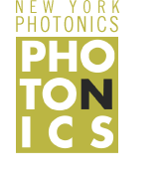 |  | Applications of Identification Using Light  Student Edition
Name: | Subject(s)/Course(s): Geometry |  | Date:
Synopsis and Narrative:
In 2016 the global diamond jewelry market was approximately 80 billion dollars. Diamonds are very expensive to mine and to produce gem quality specimens. Fake diamonds like cubic zirconia have been flooding the market for years, being bought and sold as real diamonds. The reason is because it is very difficult to distinguish between a real diamond and cubic zirconia. Diamonds are very unusual for a gemstone because they are composed of a single element, carbon. Virtually all other gemstones contain multiple elements, primarily significant amounts of oxides. Cubic zirconia is made up of zirconium dioxide (ZrO₂).
Challenging Question or Problem:
How can we design a spectrograph that will be able to identify fake diamonds from real diamonds?
Phenomenon and Manufacturing Application:
Spectroscopy is used to identify the elements present in a material. Applications include medical diagnosis through magnetic resonance imaging (MRI), material identification, determining molecular structures, chemical concentration/ identification, and quality control all rely on spectroscopy.
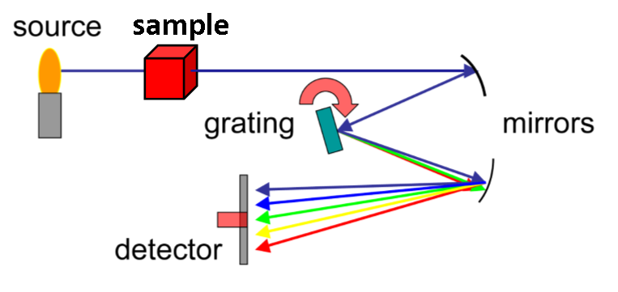  Examples (in action):  Spectroscopy in forensics has proven to be a non-destructive way to analyze different bodily fluids, drugs, or fingerprints. Analyzation of forensic materials can be on site, quick, and requires minimal to no sample preparation. A known light source is passed through or reflected off of the sample, which changes the spectrum of the known light source. These changes are analyzed using a detector to identify the sample.  By Kkmurray (Own work) [GFDL (http://www.gnu.org/copyleft/fdl.html) or CC BY-SA 3.0 (https://creativecommons.org/licenses/by-sa/3.0)], via Wikimedia Commons |  |  |  | Vocabulary:  Angle  Circle  Construction  Perpendicular Line  Parallel Line  Line Segment  Law of Sines  Pythagorean Theorem
State and National Standards & 21st Century Skills:
High School Common Core Math Standards:
G-CO #1
Know precise definitions of angle, circle, perpendicular line, parallel line, and line segment, based on the undefined notions of point, line, distance along a line, and distance around a circular arc.

G-CO #12
Make formal geometric constructions with a variety of tools and methods (compass and straightedge, string, reflective devices, paper folding, dynamic geometric software, etc). Copying a segment; copying an angle; bisecting a segment; bisecting an angle; constructing perpendicular lines, including the perpendicular bisector of a line segment; and constructing a line parallel to a given line through a point not on the line.

G-SRT #6
Understand that by similarity, side ratios in right triangles are properties of the angles in the triangle, leading to definitions of trigonometric ratios for acute angles.

G-SRT #8
Use trigonometric ratios and the Pythagorean Theorem to solve right triangles in applied problems.

G-SRT #11
Understand and apply the Law of Sines and the Law of Cosines to find unknown measurements in right and non-right triangles (e.g., surveying problems, resultant forces).

Geometry Practices
MP4. Model with Mathematics
MP5. Use appropriate tools strategically
MP6. Attend to precision

N-Q #3
Choose a level of accuracy appropriate to limitations on measurement when reporting quantities
Materials and Equipment:
Paper
Meter Stick
Three lasers – Green, Red, Blue
Diffraction Gradient
Diffraction Gradient Stand
Pencil
String
Compass
Straight Edge
Ruler
Scientific Calculator
Push Pins
Safety:
Lasers are light sources that can permanently damage the eye. They are not toys. When you are not using the laser, TURN IT OFF. Do not let the laser beam wander around the room. Always keep the laser beam below the chest area of all people in the room. Never look into the laser beam or at laser light reflected off of a shiny surface. If you stare into a laser beam for a period of time, permanent and irreparable damage to the eye can occur. The Laser BloxTM set provided in the kit is a Class IIIR laser product.
Learning Targets:
- Students will use geometric constructions to bisect a segment; bisect an angle; construct perpendicular lines, including the perpendicular bisector of a line segment; and constructing a line parallel to a given line through a point not on the line.
- Use trigonometric ratios and the Pythagorean Theorem to solve right triangles in applied problems.
- Understand and apply the Law of Sines and the Law of Cosines to determine an angle.

Introduction:
https://www.news-medical.net/life-sciences/Spectroscopy-Applications.aspx
Spectroscopy Applications
By Dr Tomislav Meštrović, MD, PhD
Spectroscopy represents a scientific measurement technique for the studying of matter through its interaction with different components of the electromagnetic spectrum. It can measure light by breaking it down into its component colors with the help of a prism in order to study the resulting spectrum.

The concept was later expanded to include any feasible interaction with radiative energy as a function of its frequency or wavelength. The outcome of such an interaction allows researchers to infer analytical information on the atomic or molecular structure of the matter.

A wide array of different spectroscopic techniques can be applied in virtually every domain of scientific research - from environmental analysis, material identification, and biomedical sciences to space exploration endeavors.
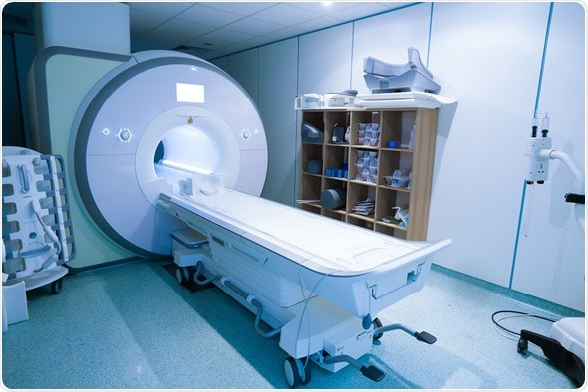
Magnetic resonance spectroscopy machine in hospital laboratory : Image Copyright: zlikovec / Shutterstock

Spectroscopy in Environmental Analysis
Visible and ultraviolet spectroscopic methods have been used for years by environmental scientists. Common colorimetric tests that probe different water properties (such as acidity) are now available in simple kit forms, employing visual color matching or portable colorimeters.

Emission spectroscopy or atomic absorption in the visible and ultraviolet regions can be used to determine metals in samples of water or solids. These approaches require immersion of the analyte into solution before analysis can be pursued. Nevertheless, certain solid or semisolid samples may be analyzed directly with atomic absorption spectrometry (by using electrothermal atomization)

Infrared spectroscopy is also a significant addition to the environmental analysts’ armamentarium, especially with the introduction of long-range infrared sensors that can determine the concentration of certain compounds in the air mass. In addition, ultraviolet long-path methods are also increasingly used, albeit not as habitually as infrared spectroscopy.

X-ray methods (such as X-ray fluorescence) can be used to determine the atomic composition of solid materials, and they also found a place in determining metal concentrations in particulate matter from the air, as well as in soil samples.

Microwave region spectroscopy and magnetic resonance spectroscopy have been implemented in some environmental research, but are not so pervasive.

Spectroscopy in Biomedical Sciences
The biomedical use of light comprises numerous diagnostic and therapeutic applications. Photon time-of-flight spectroscopy may assist certain therapeutic methods (such as photodynamic therapy) by supplying them with the data on the optical properties governing tissue response.
The reliable absorption and scattering spectroscopy (provided by the time-of-flight spectroscopy) can be of great value in diagnostics as well, which is confirmed by its recent introduction to microbiology.

Moreover, steady-state, near-infrared spectroscopy is a very significant tool in pharmaceutical analysis. The main advantage of this technique is a rapid and non-destructive approach that necessitates little or no sample preparation. In addition, the establishment of chemometrics (extracting information by data-driven means) has increased its propensity of sensing slight variations in complex datasets.

Recent breakthroughs in holographic microspectroscopy (a technique based on optical coherence tomography or quantitative phase imaging) hold promise for non-invasive, label-free optical detection and measurement of specific molecules in human cells and tissues (such as hemoglobin protein).

Other Applications
Spectroscopy also finds uses in astronomy to obtain information about the composition, density, temperature, and other principal physical processes of a certain astronomical object. By measuring red-shift (recession speed), scientists can use spectroscopy to calculate the relative velocities of supernovae and galaxies.

Raman spectroscopy can result in the vibrational spectrum of a certain analyte (often referred to as its “fingerprint”), which then allows straightforward identification and interpretation. Its potential applications range from archaeology to modern nanotechnology.
Reviewed by Susha Cheriyedath, MSc

Sources
- http://mtweb.mtsu.edu/nchong/Spectroscopy-CHEM6230.pdf
- https://solarsystem.nasa.gov/deepimpact/science/spectroscopy.cfm
- https://faculty1.coloradocollege.edu/~hdrossman/CH345WWW/spec.htm
- www.mssl.ucl.ac.uk/~gbr/workshop3/papers/Paerels_school_Mar17.pdf
- www.atomic.physics.lu.se/.../PhD_Thesis_Tomas_Svensson.pdf
- Hollas JM. Basic Atomic and Molecular Spectroscopy. Royal Society of Chemistry, Cambridge CB40WF, UK; 2002.
- Ball DW. The Basics of Spectroscopy. SPIE PRESS - The International Society of Optical Engineering, Bellingham, Washington, USA; 2001.

To identify fake diamonds you need to be able to look at the spectrum from a known light source passing through the diamond sample.

Setup (see diagram below):

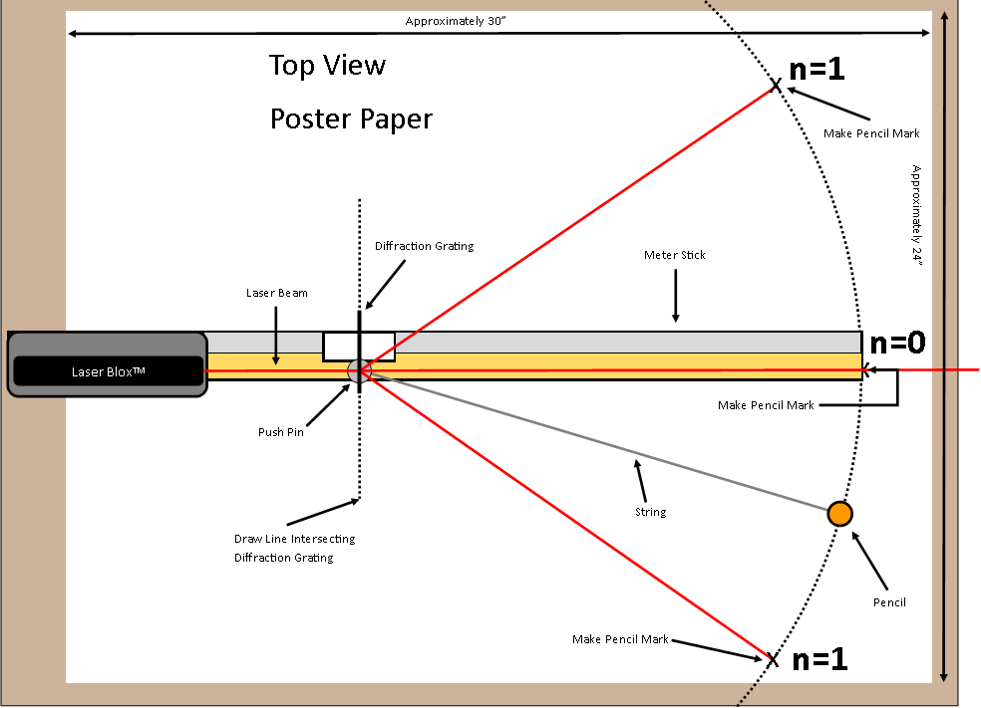
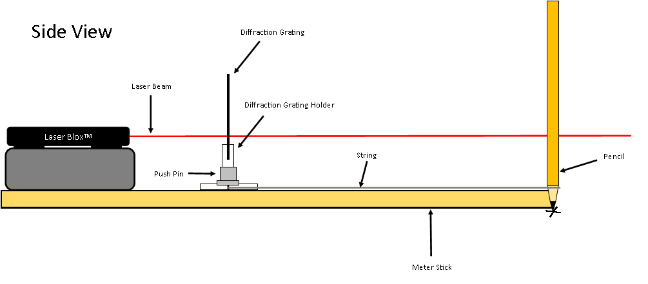
- Using the provided poster paper, cut and tape a large sheet of paper with minimum dimensions of 30” x 24” to the table.

- Lay the meter stick on the paper so that the edge of the stick is approximately one inch away from the edge of the paper and centered on the paper in the other direction.

- At the far end of the paper and meter stick, place the laser pointer support block on top of the meter stick and then the laser pointer on top of the block, pointing towards the other end of the paper.
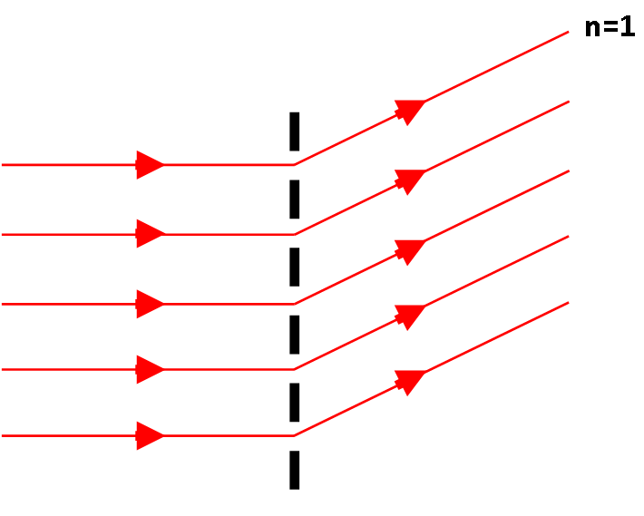
Diffraction gratings contain thousands of very small slits, or rulings, where the light will spread out and change direction as it passes through the small openings. The laser that you are using today contains light of only one color or wavelength. Light with multiple colors or wavelengths would be broken up into their component colors or wavelengths.

- Place the diffraction grating in the white diffraction grating stand, making sure the stand only comes in contact with the cardboard frame. Place the diffraction grating and the stand on the meter stick between the laser and the end of the meter stick.

- Place the push pin on the wood part of the meter stick directly underneath the diffraction grating. Do not place the push pin on the ruled tape.

- Tie one end of the string around the push pin and the other end around a pencil at so that the string is taut and the pencil extends right to the end of the meter stick.

- Turn the laser pointer on and align it so that it goes through the diffraction grating and is parallel to the meter stick. Use an index card or your finger to locate the laser, DO NOT LOOK DIRECTLY AT THE LASER!

- Mark an X on the paper at the end of the meter stick in the line of the laser beam. This will become n=0 (zero order) of the diffraction.

Gathering Data:
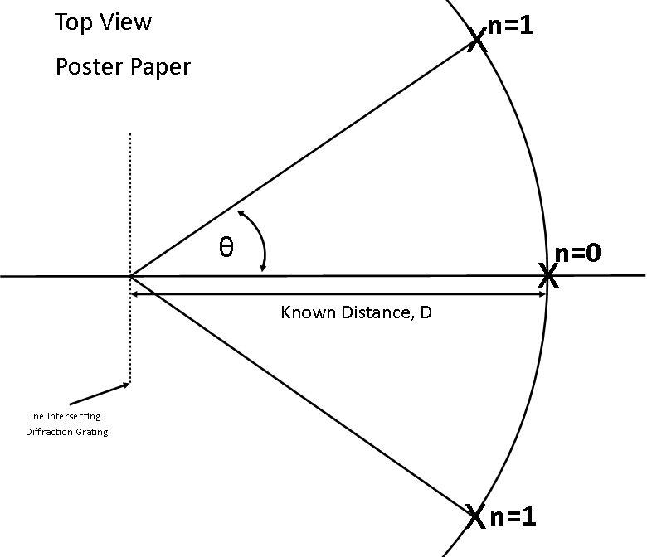
- Create an arc with the pencil attached to the string and the push pin.

- Mark an X along the arc where the laser beam is at n=1.
n=1 is where there is constructive interference from the diffraction grating. See the diagram below for where n=1 can be found. Constructive interference from the grating occurs when the path difference from two rays that are interacting with each other is a whole wavelength.

- Draw a line connecting each X to the center point intersecting the diffraction grating. With the meter stick and paper removed it should look like the diagram below.

- Using the materials given to you, determine the angle θ between n=1 and n=0. Show all work in the box below.

Deriving the Equation and Finding the Wavelength:
- Constructive interference from the grating occurs when the path difference, λ from two rays that are interacting with each other is a whole wavelength. This path difference can be determined using geometry. Using the diagram below, come up with an expression that allows you to find the wavelength of light, λ based on the angle θ. Show all work in the box below.

- The variable d is the distance between slits or rulings on the diffraction grating. The number of slits or rulings on the diffraction grating is written as the number of lines per mm on the diffraction grating. Determine the distance in mm between each slit or ruling in millimeters and then convert that to inches. (there are 25.4 millimeters in an inch)

- Using the angle θ you found earlier, and the distance between the slits or rulings, d, determine the wavelength of light, λ being used. Show all work below.

- The actual wavelength of the laser being used is written on the laser. They are: Red: 6.35x10⁻⁷ m or 2.50x10⁻⁵ in, Green: 5.32x10⁻⁷ m or 2.09x10⁻⁵ in, and Blue: 4.05x10⁻⁷ m or 1.59x10⁻⁵ in. Find the percent error between the value that you got and the wavelength given. Show all work below.

Material Confirmation for Diamonds
Material confirmation is a technique that is extensively used in the pharmaceutical industry. A pharmacy can ensure that incoming drug is labeled correctly by comparing a drugs reference spectra to the receiving drugs spectra. If there is a match of spectral absorption lines corresponding to specific wavelengths between the reference drug and the drug received, the pharmacy can confirm its authenticity.

Because diamond is made up of one element (carbon) its reference spectrum is quite unique. There are two absorption lines that define a diamond due to carbon, one at 3.30x10⁻⁶ m or 1.30x10⁻⁴ in, and another at
2.85x10⁻⁶ m or 1.12x10⁻⁴ in. Using this material confirmation technique, design a spectrograph that will allow someone to quickly confirm that a diamond is authentic based on the two absorption lines found in the reference spectra characteristics.

